**SVKM’s NMIMS**

**Mukesh Patel School of Technology Management and Engineering**

**Department of Computer Engineering**

A SYNOPSIS ON

**“Mental Health App”**

By

**Madiha Mansoori**

**Hrishil Maliwal**

**Sharvil Kotian**

**Hersh Kenkre**

**B.Tech – B**

**August 2021**

# Index

Contents

Index 2

Motivation 3

Problem Statement 4

Architecture 5

Implementation 6

Tentative Timeline 6

Impact 7

References 8

# Motivation

Mental disorders affect a large percentage of the global population in their lives. Every year, approximately 25% of adults and 10% of children are affected. The most common mental disorders are depressive disorders and anxiety disorders. In 2017, 322 million people suffered from depressive disorders and 264 million from anxiety disorders worldwide. Apart from the fact that mental disorders impact on people’s quality of life, they are one of the most common causes of occupational disability leading to high economic losses. Mental disorders are usually treated by pharmacotherapy or psychotherapy. However, there is a huge global shortage of human resources for delivering such mental health services. In developed countries there are nine psychiatrists per 100,000 people available, while in developing countries there is one psychiatrist per ten million people. When put into perspective this number is very low when compared to other types of medical experts. Apart from the shortage of resources, a stigma also exists around the idea of getting and receiving necessary help for a healthy mental state, people are afraid to speak up and seek the help they need, because they are afraid of what the society might think. This is one of the biggest issues that we aim to tackle in our project. We want to create an application, a safe space of sorts, where users can get the help they need without worrying about society. Leaving people with mental disorders untreated can increase suicide attempts and mortality. To address this problem, conversational agents have arisen interest in recent years, particularly in psych education, behaviour change and self-help.

# Problem Statement

The aim of our project is to streamline the process of attaining help for mental health disorders. In recent years the amount of stress has spiked drastically among the youth due to increased competitiveness. Mental health issues have been openly discussed in the past as well, but recently, due to the COVID-19 pandemic, they did finally received the mass attention that they needed all along. Although apps exist in the market, they have issues like, language barriers, they lack proper interface or UI, their models are inadequately trained, they lack human-like comfort, they lack of additional features etc.

We aim to create an application whose primary focus is a chatbot trained on the Counselchat dataset, which will be obtained by web scrapping the website ‘https://counselchat.com/’ and uses the PHQ-9, WHO-5 questionnaires to determine the mental state of the user. It will additionally have a mood journal, emotion tracker and a mental health resource book for the users.

# Architecture

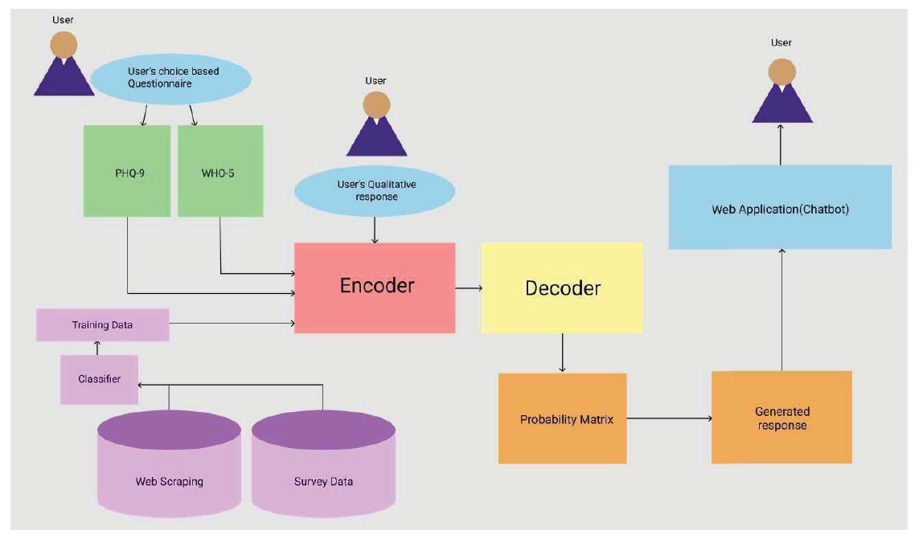

*Fig. 1. Basic architecture of CareBot[2]*

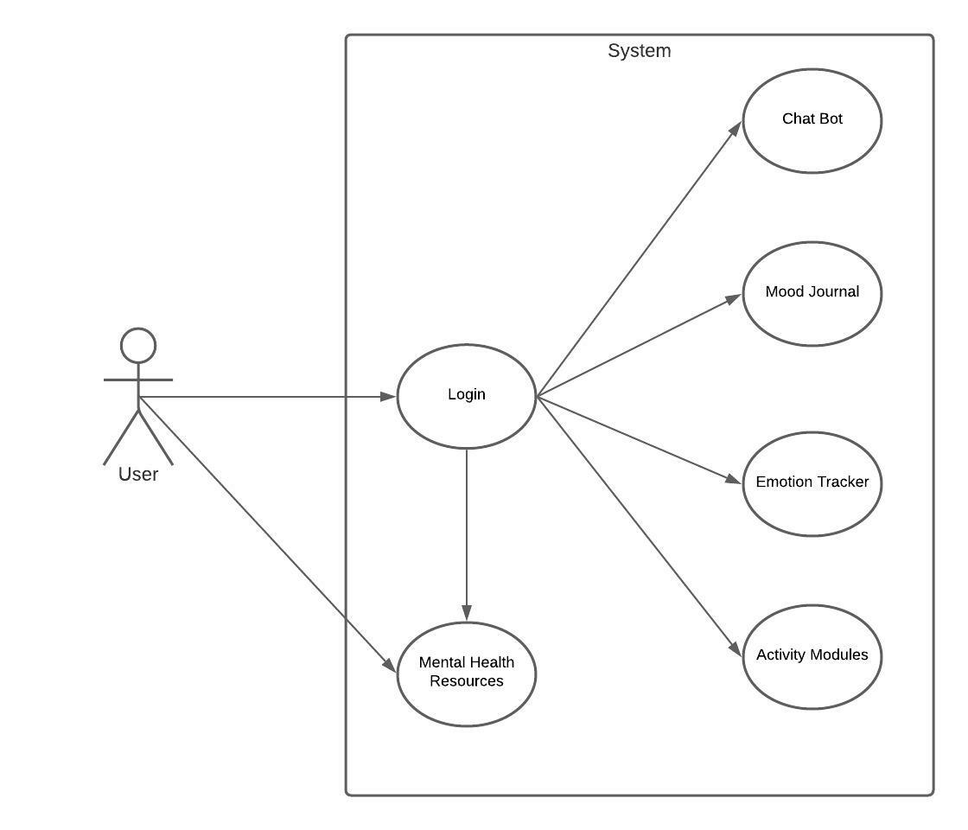

*Fig. 2. Use-Case diagram of the application*

# Implementation

# Tentative Timeline

# Impact

Society will gain a lot from the application, because just like any illness, mental illness can also disrupt one’s day to day life. Our application will help these people take the first step towards a health mental state. The stigma that exists around mental health does not allow people to speak up and ask for the necessary help. They are afraid that, society will judge them and think that something is wrong with mentally and that they are in need of therapy. Our app will help all these people that are afraid of the judgement put on them by the society, as they can use the app without letting anyone know about it.

# References

1. K. Denecke, S. Vaaheesan, and A. Arulnathan, “A Mental Health Chatbot for Regulating Emotions (SERMO) - Concept and Usability Test,” IEEE Trans. Emerg. Top. Comput., vol. 14, no. 8, 2020, doi: 10.1109/TETC.2020.2974478.
2. R. Crasto, L. Dias, D. Miranda, and D. Kayande, “CareBot: A Mental Health ChatBot,” pp. 1–5, 2021, doi: 10.1109/incet51464.2021.9456326.
3. A. Ghandeharioun, D. McDuff, M. Czerwinski, and K. Rowan, “EMMA: An Emotion-Aware Wellbeing Chatbot,” 2019 8th Int. Conf. Affect. Comput. Intell. Interact. ACII 2019, pp. 15–21, 2019, doi: 10.1109/ACII.2019.8925455.
4. P. Das Monalisa and S. Kumar, “A Chatbot System For Mental Health Care,” pp. 1–5.